|  |  |  |  |  |
| --- | --- | --- | --- | --- |
|  | | | | |
|  |  |  | |  |
| NETWORK ARCHITECTURE REPORT  Data Communication & Networks  Group No: 28 | | |
| mit corporation | | info@students.nsbm.ac.lk |

|  |  |  |  |  |
| --- | --- | --- | --- | --- |
|  | | | | |
|  |  |  | |  | |
|  | ABOUT US  We are a group of six motivated students from NSBM Green University who are passionate about network architecture design and information technology. We're eager to share the results of our project, which focuses on developing a network architecture diagram for MIT Corporation.  For MIT Corporation, our goal has been to provide a framework for a scalable, secure, and dependable network. We used cutting-edge technologies, relevant case studies, and industry experts to accomplish this. Our system combines reliable network protocols, powerful hardware architecture, effective data flow management, and comprehensive security. | |  | |

Table of Contents

ABOUT US 2

mit corporation 4

Network Architecture 4

developer building 6

Wired Transmission Media 6

ADMINISTRATION BUILDING 10

MAIN BUILDING 15

workload matrix 18

REFERENCEs 18

|  |  |
| --- | --- |
|  |  |
| mit corporationNetwork Architecture The MIT corporation is consisted of three building which are Main Building (X), Developer Building (Y), Administration Building (Z) withing 25 acres in the city of Homagama. Therefore, we have made a main diagram for the whole corporation. Which is shows below. In addition to that we have made separate Computer Network Architectural Graphs for each building which we have explained and listed the Technology and the Hardware Devices we have used to develop and design the Architecture. | |
|  | |  |
| Main Building | |  |
|  | |  |

|  |  |  |  |
| --- | --- | --- | --- |
|  | |  | |
| developer building We recommend applying both wired and wireless transmission techniques to enable seamless connection between corporate buildings. Each approach has advantages of its own and can be strategically applied depending on the communication requirements. Wired Transmission Media  * Wired transmission methods are dependable and capable of providing connections that are both fast and secure. The following wired mediums are implemented taking into account the design and specifications of the MIT buildings: * The following hardware components we have used after carefully considering the reliability and the cost.  1. Ethernet Cabling   Setting up a reliable, high-bandwidth network within each building is possible using Ethernet cabling, more precisely Category 6 (Cat6) or above. This cable allows effective communication between PCs, printers, servers, and other network devices and is capable of supporting data rates of up to 10 Gbps. The internal network infrastructure will have a solid basis thanks to the widespread installation of Ethernet cabling.  Therefore, we have used ethernet cables within the building to make the connection more reliable and efficient.   1. Fiber Optic Cabling   Fiber optic cabling allows significantly faster data transmission speeds and greater resistance to electromagnetic interference. For connecting the three buildings, we decided using fiber optic cabling. As a result, communication between the main building (X), developer building (Y), and administrative building (Z) will be dependable and quick. The bandwidth demands of contemporary IT settings can readily be supported by fiber optic cabling.  Therefore, the building is connected with the other buildings using the fiber optic cables.   1. Router   A router has used to connect the devices in a star topology.  **Wireless Transmission Media**   * Employees can connect to the network without any physical restrictions because to the freedom and mobility that wireless transmission mediums offer. We advise using the following wireless mediums because of the requirements for mobile connectivity and the nature of some tasks: * In addition to the wired connectivity, we have also made an alternative which is wireless method. If in case the wired connection had a failure the wireless connection allows the users to use the resources without a failure.  1. WIFI Access Point   Wi-Fi-enabled devices such as laptops, cellphones, and other devices will be able to connect wirelessly thanks to the deployment of Wi-Fi access points on every floor of the buildings. Employees will have the option to operate from various locations inside the buildings thanks to the network's simplicity of access.  Therefore, we have included WIFI access point within the building which has two separate ssid’s one for Guest and other one for employees.   1. Bluetooth   Short-range wireless connections using Bluetooth technology are particularly useful for connecting peripheral devices like printers. Employees can effortlessly send print jobs wirelessly without the need for physical connections by turning on Bluetooth capabilities on the printers.  Each computer and printer in the building has the Bluetooth function they can either share or connected using the Bluetooth method also.  **Topology Used**   * We have used ring topology with the use of router as it is the best option to connect all the devices without less failures and much more efficient manner which makes the developer’s building architecture more reliable.   **Conclusion**   * We suggested and combined wired and wireless transmission methods to create a thorough communication network throughout the MIT buildings and within the Developer’s Building. The basis for dependable and high-bandwidth communications both inside and between the buildings will be Ethernet and fiber optic cabling. Wireless networking options with greater flexibility and use will be made available by Wi-Fi and Bluetooth. By putting this suggested transmission medium setup into practice, MIT will be able to build a solid IT infrastructure that supports effective communication and boosts productivity throughout the business.   **Layout of the Developer’s Building** | | | |
|  |  | |  |
|  |  | |  |

|  |  |
| --- | --- |
|  |  |
| ADMINISTRATION BUILDING We suggested combining wired and wireless transmission techniques to create seamless connectivity at the MIT corporation's Administration Building, which houses 35 computers and 20 printers. This strategy will provide effective and dependable communication inside the structure.  **Wired Transmission**   * The following hardware components we have used after carefully considering the reliability and the cost.  1. Ethernet Cabling   To build a dependable and high-bandwidth network inside the Administration Building, we have installed Ethernet cable, specifically Category 6 (Cat6) or above. This will make it possible for PCs, printers, and other network devices to communicate quickly and securely.   1. Fiber Optic Cabling   Significantly faster data transmission speeds and greater immunity to electromagnetic interference are made possible by fibre optic wiring. We chose fibre optic cabling to connect the three buildings. As a result, there will be reliable and prompt communication between the administration building (Z), developer building (Y), and main building (X). Fibre optic cabling can easily satisfy the bandwidth requirements of modern IT setups.  As a result, fiber optic cables are used to connect the building to the other structures.   1. Router   A router has used to connect the devices in a star topology.  **Wireless Transmission Media**   * As in the Developers Building we have also included wireless transmission method using wifi access point in which if the wired media failed, the employees can do their job without any failure using the wireless method of connection.  1. WIFI Access Point   The installation of Wi-Fi access points on each floor of the buildings will allow devices that support wireless connections, including laptops, telephones, and other gadgets. The network's ease of access will allow employees to work from a variety of locations inside the buildings.  As a result, we have a WIFI access point with two different SSIDs—one for guests and the other for staff—included in the building.  If a failure arises in the wired method the systems and devices will automatically switch to the wireless method seamlessly.   1. Bluetooth   Bluetooth-based short-range wireless connections are particularly helpful for connecting peripheral devices like printers. By enabling Bluetooth on the printers, staff can easily send print jobs wirelessly without the need for physical connections.  Every computer and printer in the building has Bluetooth functionality, allowing them to be connected or shared.   1. Topology Used   As the above building structure, we have also decided to use the star topology to this building also due to its effectivity and the reliability. Star connection would be the best fit for all the buildings in the organization.  **Conclusion**  In order to establish a full communication network throughout the MIT buildings and inside the Developer's Building, we offered and combined wired and wireless transmission techniques. Ethernet and fiber optic cabling will serve as the foundation for dependable and high-bandwidth communications both within and between the buildings. Wi-Fi and Bluetooth will provide wireless networking options with more adaptability and utilization. MIT will be able to create a strong IT infrastructure that facilitates efficient communication and raises productivity across the board by putting this suggested transmission medium setup into practice.  LAYOUT OF ADMINISTRATER BUILDING | |

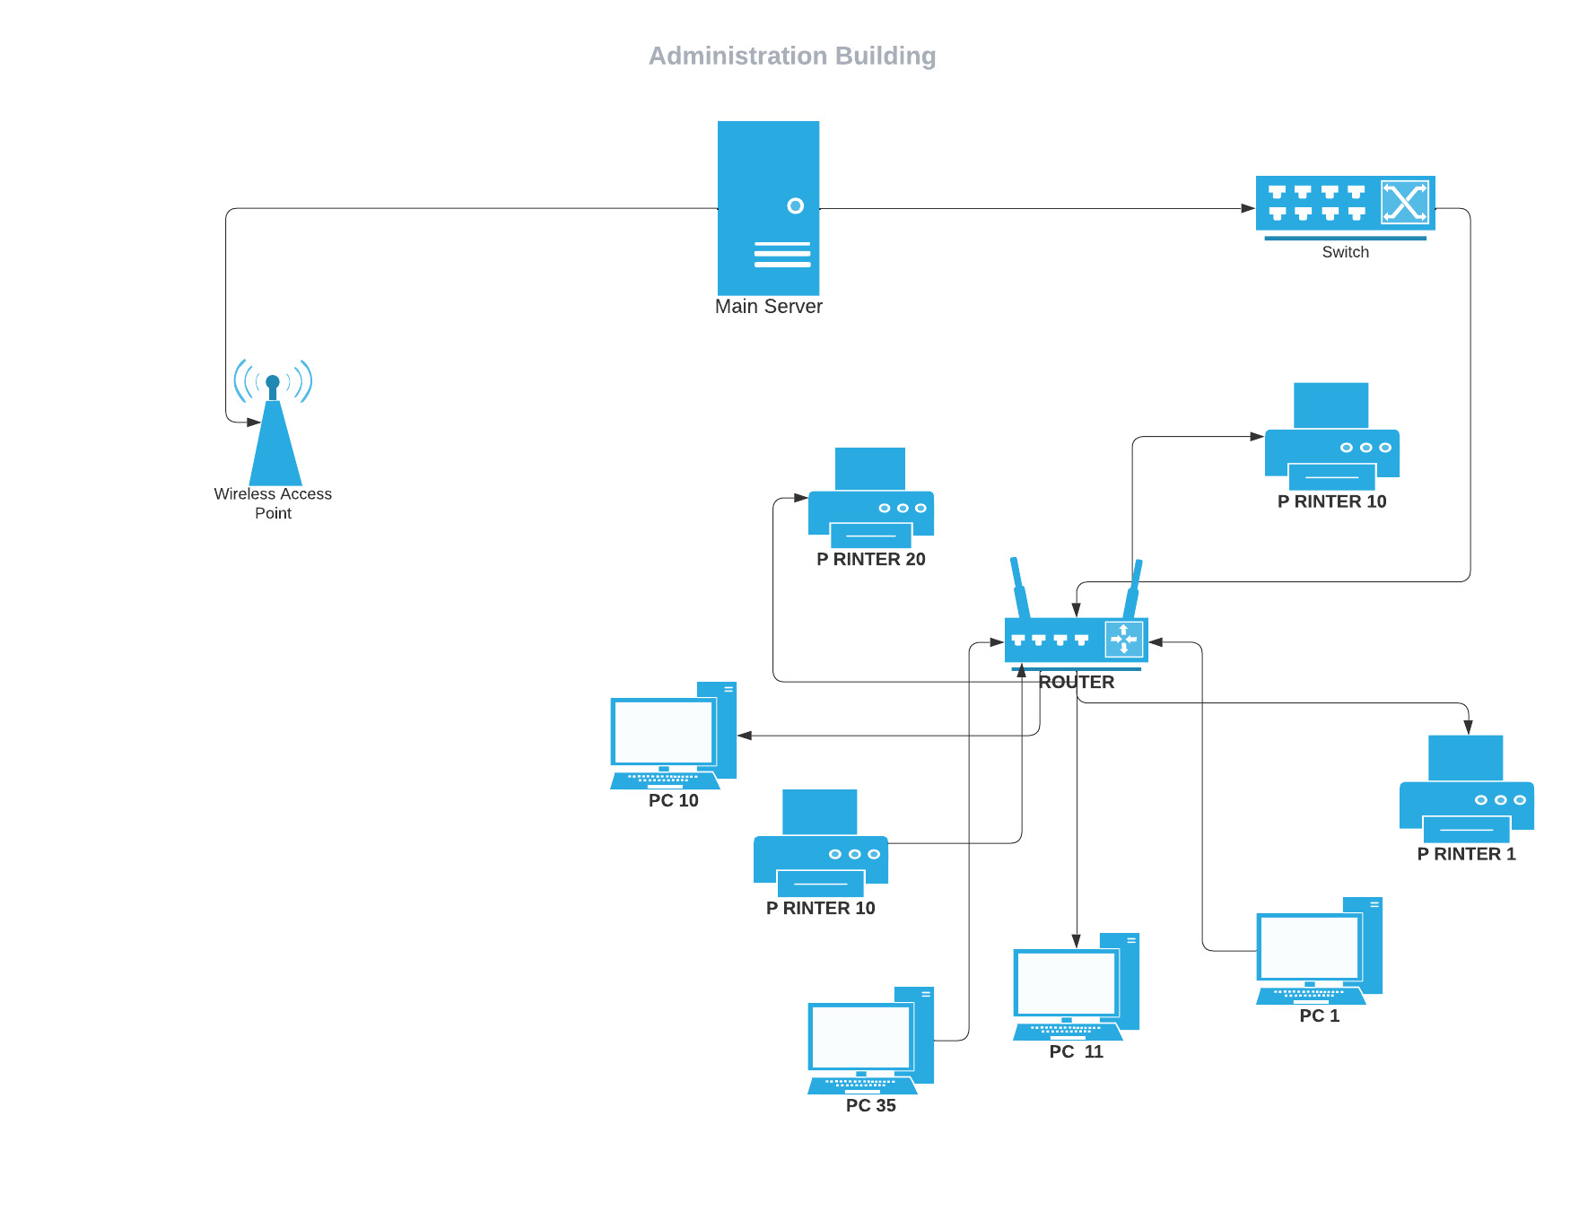

|  |  |
| --- | --- |
|  |  |
| MAIN BUILDING Provide network connectivity to the whole building, we can use wired or wireless combination of transmission mediums. It’s like this.   * Ethernet Cables: - We can use Ethernet cables for wired connection between computers, printers and networking devices. * WIFI: - We can fix WIFI Access Points to provide wireless connectivity to devices through the building.   When setup this network infrastructure, we needed the following Materials.   1. Ethernet Cables.  * Enough Lengths of Ethernet cables to connect the computers and printers on each floor to network equipment’s as switches , routers etc.  1. Network Switches  * Need Two switches (one floor need one switch) to provide proper connection between computers, printers and other devices on the floor.  1. Wifi Access Points    * + Considering the Building size and layout of network we need wifi access points to providing proper coveragable wireless connectivity. 2. Network Router    * + A router use for connect the local network to the internet service provider (ISP) and manage the network traffic. 3. Power Outlets      * Provide Enough power outlets near the devices to provide electricity everytime | |
|  | |
| **Referred Follow Steps before the sharing Internet Connection Among the Employees and Guests.**   1. Router Configuration.   Set up network router and connect to the Internet Service Provider (ISP) for provide proper internet access to the X building.  Using Necessary network methods configure the router including ISP- Provided information. These are Ip addresses, DHCP, DNS Servers.   1. Create Virtual Local Area Networks   Divide into separate VLANs to limit the employee and guest traffic.VLANs assign different range of Ip addresses.   1. Install Network Security tools, like WPA2 and WPA3 encryption, to safeguard the WIFI network and the data of its users. 2. Make distinct WIFI networks with their own passwords and access controls for both employees and visitors. This ensures that visitors have restricted access to internal resources and guards the main network’s security. 3. To manage visitor access and obtain relevant data, you can set up a captive portal and guest authentication system as needed. 4. Set Bandwidth Limits and QOS   Configure the router’s Quality of service (Qos) Settings to give employee traffic priority over guest traffic. This makes sure that employees’ internet experiences are better and faster than those of visitors. You can also place bandwidth restrictions on visitors to stop them from using up too much of your network’s resources.  By following these instructions, we were able to successfully share the internet connection between employees and guests while ensuring network security and offering a positive user experience for both groups. | |

LAYOUT OF MAIN BUILDING

# workload matrix

|  |  |  |
| --- | --- | --- |
| Name | NSBM ID | Contribution (%) |
| J. M.S.V JAYAWEERA | 29008 | Report Creation  Administration Building |
| P.C.D AMARATHUNGA | 28557 | Main Building |
| P.R DHARMAWANSHA | 28580 | Main Building |
| M.C.P KUMARA | 28580 | Developers Building |
| A.P.M PREMASIRI | 26033 | Developers Building |
| J.A.N AMBILLAWALA | 28941 | Administration Building |

# REFERENCEs

Books:

1. Forouzan, B. A. (2013). "Data Communications and Networking." McGraw-Hill Education.

2. Tanenbaum, A. S., & Wetherall, D. J. (2011). "Computer Networks." Pearson.

Websites:

1. Cisco. (n.d.). "Understanding the OSI Reference Model." Cisco. https://www.cisco.com/c/en/us/support/docs/ip/routing-information-protocol-rip/13788-3.html

2. Techopedia. (n.d.). "Open Systems Interconnection (OSI) Model." Techopedia. https://www.techopedia.com/definition/4994/open-systems-interconnection-osi-model

3. Study.com. (n.d.). "The 7 Layers of the OSI Model." Study.com. https://study.com/academy/lesson/the-7-layers-of-the-osi-model.html

4. GeeksforGeeks. (n.d.). "Introduction of Network Architecture." GeeksforGeeks. https://www.geeksforgeeks.org/introduction-of-network-architecture/

Remember to adapt the formatting based on the specific requirements of the Harvard referencing style used in your institution or organization. Always provide complete and accurate information for each source to ensure proper citation and acknowledgment of the authors' work.